**AWS RESOURCE LISTING AUTOMATION SCRIPT**

**Purpose:**  
The script was created to **automate and standardize the process of discovering and listing AWS resources** across multiple services in an account. It helps administrators and developers **quickly get an inventory of resources** without manually running separate AWS CLI commands for each service, saving time and reducing human error.

**Explanation :**

* The script accepts **two inputs**: the AWS region and the target service (e.g., EC2, S3, Lambda).
* It validates that the **AWS CLI is installed and configured**.
* A **case statement** determines which AWS CLI command to run for each service (e.g., describe-instances, list-buckets, list-functions).
* **Global services** like S3 and IAM are handled without requiring a region.
* Results are printed in a **structured format** showing key identifiers for easy review or further processing.
* Includes **error handling** for invalid inputs, missing configuration, and unsupported services.

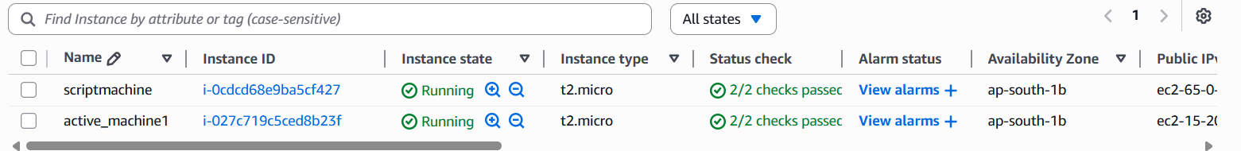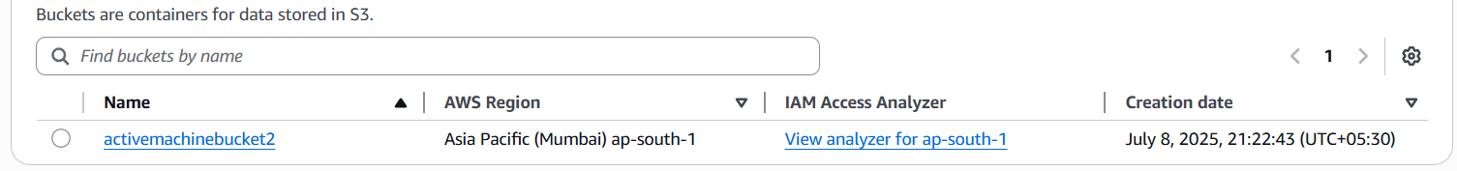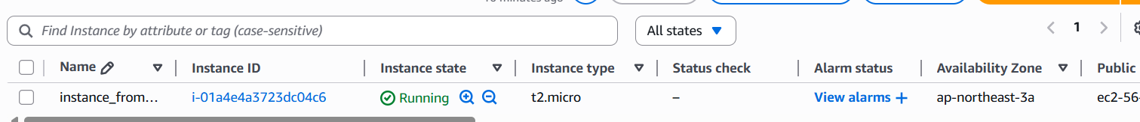**OUTPUT**

